# 任务单 碎片的创建与使用

## 演示任务

**1、创建两个碎片**

**（1）创建碎片AFragment,布局文件为fragment_a，在碎片内左上角放置文本显示框tv_show，显示“碎片1”。**

**（2) 创建碎片BFragment,布局文件为fragment_b，在碎片内左上角放置文本显示框，显示“碎片2”。**

**2、将碎片放入界面中**

**主界面采用垂直线性布局，2个碎片各占主界面的二分之一。**

**3、修改碎片的布局**

**（1）在碎片AFragment内增加一个编辑框edt_name、一个按钮btn_ok。**

**（2）设置碎片BFragment的背景颜色为#aabbcc。**

**（3）查看主界面的显示效果是否如下图所示。**

**4、碎片的事件处理**

**实现碎片AFragment内按钮的功能，点击按钮btn_ok可将用户在编辑框儿edt_name输入的内容显示在文本框tv_show中。**

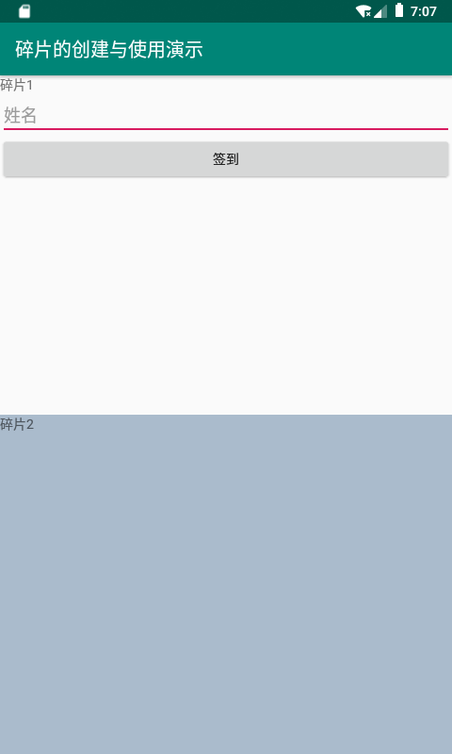

**练习任务**

**设置屏幕显示方向为水平方向，采用水平线性布局。界面内左右各添加一个碎片，布局如下图所示。实现碎片2内按钮的功能，点击按钮“点我计数”时，下面文本框显示的数字增加1。**

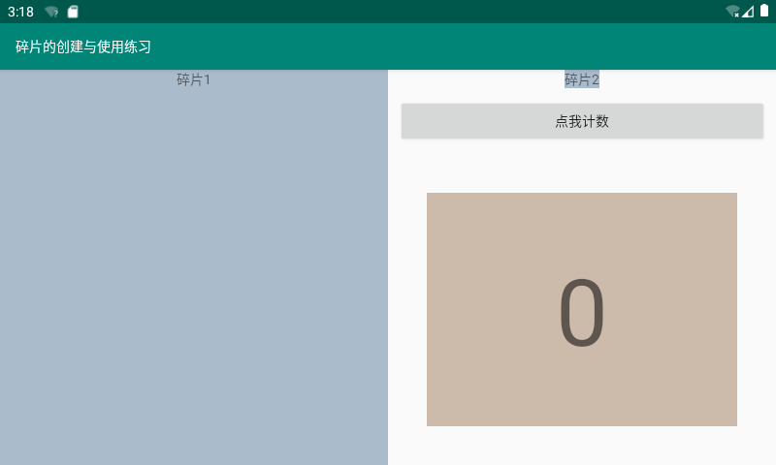

**=======提交规范=======**

**提交word文档，对应在每个任务下面添加程序代码，以姓名作为文件名。**

截图：

演示任务

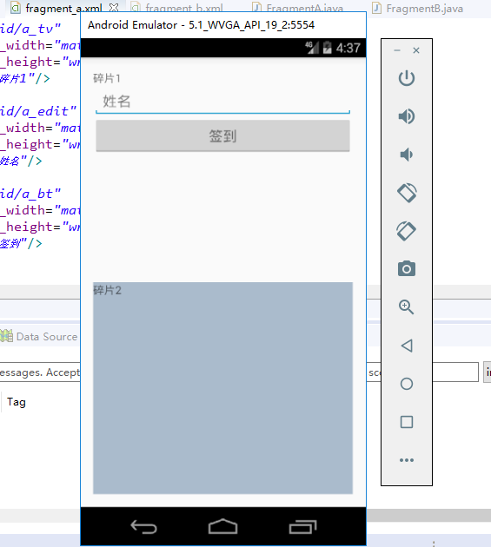

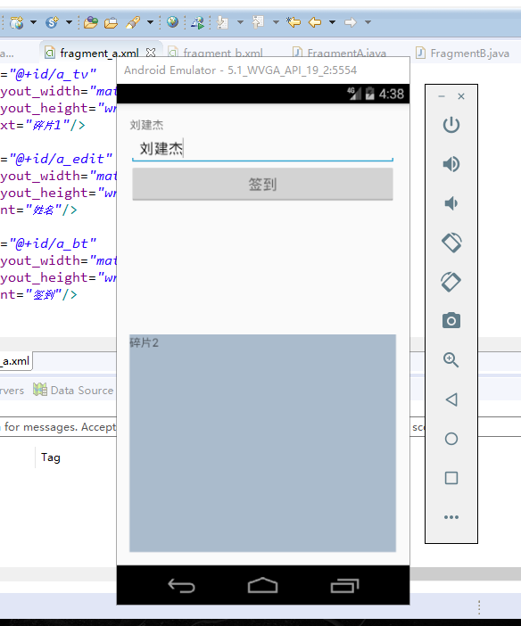

练习任务

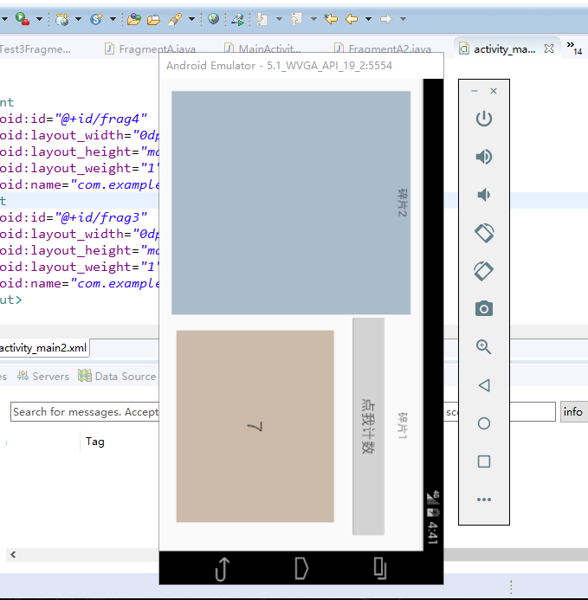

**代码：**

**演示任务**

**MainActivity.java**

**package** com.example.test3fragment;

**import** android.os.Bundle;

**import** android.support.v4.app.FragmentActivity;

**public** **class** MainActivity **extends** FragmentActivity {

@Override

**protected** **void** onCreate(Bundle savedInstanceState) {

**super**.onCreate(savedInstanceState);

setContentView(R.layout.***activity_main***);

}

}

**FragmentA.java**

**package** com.example.test3fragment;

**import** android.os.Bundle;

**import** android.support.v4.app.Fragment;

**import** android.view.LayoutInflater;

**import** android.view.View;

**import** android.view.View.OnClickListener;

**import** android.view.ViewGroup;

**import** android.widget.Button;

**import** android.widget.EditText;

**import** android.widget.TextView;

**public** **class** FragmentA **extends** Fragment{

TextView showtv;

EditText ed;

@Override

**public** View onCreateView(LayoutInflater inflater, ViewGroup container, Bundle savedInstanceState) {

View view = inflater.inflate(R.layout.***fragment_a***, container, **false**);

showtv = view.findViewById(R.id.***a_tv***);

ed = view.findViewById(R.id.***a_edit***);

Button bt = view.findViewById(R.id.***a_bt***);

bt.setOnClickListener(**new** OnClickListener() {

@Override

**public** **void** onClick(View arg0) {

// **TODO** Auto-generated method stub

showtv.setText(ed.getText().toString());

}

});

**return** view;

}

}

**FragmentB.java**

**package** com.example.test3fragment;

**import** android.os.Bundle;

**import** android.support.v4.app.Fragment;

**import** android.view.LayoutInflater;

**import** android.view.View;

**import** android.view.ViewGroup;

**public** **class** FragmentB **extends** Fragment{

@Override

**public** View onCreateView(LayoutInflater inflater, ViewGroup container, Bundle savedInstanceState) {

View view = inflater.inflate(R.layout.***fragment_b***, container, **false**);

**return** view;

}

}

**activity_main.xml**

<?xml version=*"1.0"* encoding=*"utf-8"*?>

<LinearLayout xmlns:android=*"http://schemas.android.com/apk/res/android"*

xmlns:tools=*"http://schemas.android.com/tools"*

android:layout_width=*"match_parent"*

android:layout_height=*"match_parent"*

android:paddingBottom=*"@dimen/activity_vertical_margin"*

android:paddingLeft=*"@dimen/activity_horizontal_margin"*

android:paddingRight=*"@dimen/activity_horizontal_margin"*

android:paddingTop=*"@dimen/activity_vertical_margin"*

tools:context=*"com.example.test3fragment.MainActivity"*

android:orientation=*"vertical"* >

<fragment

android:id=*"@+id/frag1"*

android:layout_width=*"match_parent"*

android:layout_height=*"0dp"*

android:layout_weight=*"1"*

android:name=*"com.example.test3fragment.FragmentA"*/>

<fragment

android:id=*"@+id/frag2"*

android:layout_width=*"match_parent"*

android:layout_height=*"0dp"*

android:layout_weight=*"1"*

android:name=*"com.example.test3fragment.FragmentB"*/>

</LinearLayout>

**fragment_a.xml**

<?xml version=*"1.0"* encoding=*"utf-8"*?>

<LinearLayout xmlns:android=*"http://schemas.android.com/apk/res/android"*

android:layout_width=*"match_parent"*

android:layout_height=*"match_parent"*

android:orientation=*"vertical"* >

<TextView

android:id=*"@+id/a_tv"*

android:layout_width=*"match_parent"*

android:layout_height=*"wrap_content"*

android:text=*"碎片1"*/>

<EditText

android:id=*"@+id/a_edit"*

android:layout_width=*"match_parent"*

android:layout_height=*"wrap_content"*

android:hint=*"姓名"*/>

<Button

android:id=*"@+id/a_bt"*

android:layout_width=*"match_parent"*

android:layout_height=*"wrap_content"*

android:hint=*"签到"*/>

</LinearLayout>

**fragment_b.xml**

<?xml version=*"1.0"* encoding=*"utf-8"*?>

<LinearLayout xmlns:android=*"http://schemas.android.com/apk/res/android"*

android:layout_width=*"match_parent"*

android:layout_height=*"match_parent"*

android:orientation=*"vertical"*

android:background=*"#aabbcc"*>

<TextView

android:id=*"@+id/b_tv"*

android:layout_width=*"match_parent"*

android:layout_height=*"wrap_content"*

android:text=*"碎片2"*/>

</LinearLayout>

**演示任务**

**MainActivity2.java**

**package** com.example.test3fragment;

**import** android.os.Bundle;

**import** android.support.v4.app.FragmentActivity;

**public** **class** MainActivity2 **extends** FragmentActivity {

@Override

**protected** **void** onCreate(Bundle savedInstanceState) {

**super**.onCreate(savedInstanceState);

setContentView(R.layout.***activity_main2***);

}

}

**FragmentA2.java**

**package** com.example.test3fragment;

**import** android.os.Bundle;

**import** android.support.v4.app.Fragment;

**import** android.view.LayoutInflater;

**import** android.view.View;

**import** android.view.View.OnClickListener;

**import** android.view.ViewGroup;

**import** android.widget.Button;

**import** android.widget.TextView;

**public** **class** FragmentA2 **extends** Fragment{

TextView showcountv;

**int** count = 0;

@Override

**public** View onCreateView(LayoutInflater inflater, ViewGroup container, Bundle savedInstanceState) {

View view = inflater.inflate(R.layout.***fragment_a2***, container, **false**);

showcountv = view.findViewById(R.id.***a2_tvshowcount***);

Button bt = view.findViewById(R.id.***a2_bt***);

bt.setOnClickListener(**new** OnClickListener() {

@Override

**public** **void** onClick(View arg0) {

// **TODO** Auto-generated method stub

showcountv.setText(++count+"");

}

});

**return** view;

}

}

**FragmentB2.java**

**package** com.example.test3fragment;

**import** android.os.Bundle;

**import** android.support.v4.app.Fragment;

**import** android.view.LayoutInflater;

**import** android.view.View;

**import** android.view.ViewGroup;

**public** **class** FragmentB2 **extends** Fragment{

@Override

**public** View onCreateView(LayoutInflater inflater, ViewGroup container, Bundle savedInstanceState) {

View view = inflater.inflate(R.layout.***fragment_b2***, container, **false**);

**return** view;

}

}

**activity_main2.xml**

<?xml version=*"1.0"* encoding=*"utf-8"*?>

<LinearLayout xmlns:android=*"http://schemas.android.com/apk/res/android"*

xmlns:tools=*"http://schemas.android.com/tools"*

android:layout_width=*"match_parent"*

android:layout_height=*"match_parent"*

android:paddingBottom=*"@dimen/activity_vertical_margin"*

android:paddingLeft=*"@dimen/activity_horizontal_margin"*

android:paddingRight=*"@dimen/activity_horizontal_margin"*

android:paddingTop=*"@dimen/activity_vertical_margin"*

tools:context=*"com.example.test3fragment.MainActivity2"*

android:orientation=*"horizontal"* >

<fragment

android:id=*"@+id/frag4"*

android:layout_width=*"0dp"*

android:layout_height=*"match_parent"*

android:layout_weight=*"1"*

android:name=*"com.example.test3fragment.FragmentB2"*/>

<fragment

android:id=*"@+id/frag3"*

android:layout_width=*"0dp"*

android:layout_height=*"match_parent"*

android:layout_weight=*"1"*

android:name=*"com.example.test3fragment.FragmentA2"*/>

</LinearLayout>

**fragment_a2.xml**

<?xml version=*"1.0"* encoding=*"utf-8"*?>

<LinearLayout xmlns:android=*"http://schemas.android.com/apk/res/android"*

android:layout_width=*"match_parent"*

android:layout_height=*"match_parent"*

android:orientation=*"vertical"* >

<TextView

android:id=*"@+id/a2_tv"*

android:layout_width=*"match_parent"*

android:layout_height=*"wrap_content"*

android:gravity=*"center"*

android:text=*"碎片1"*/>

<Button

android:id=*"@+id/a2_bt"*

android:layout_width=*"match_parent"*

android:layout_height=*"wrap_content"*

android:layout_marginTop=*"10dp"*

android:layout_marginBottom=*"20dp"*

android:hint=*"点我计数"*/>

<TextView

android:id=*"@+id/a2_tvshowcount"*

android:layout_width=*"match_parent"*

android:layout_height=*"200dp"*

android:layout_marginLeft=*"20dp"*

android:layout_marginRight=*"20dp"*

android:textSize=*"26sp"*

android:gravity=*"center"*

android:background=*"#CCBBAA"*

android:text=*"0"*/>

</LinearLayout>

**fragment_b2.xml**

<?xml version=*"1.0"* encoding=*"utf-8"*?>

<LinearLayout xmlns:android=*"http://schemas.android.com/apk/res/android"*

android:layout_width=*"match_parent"*

android:layout_height=*"match_parent"*

android:orientation=*"vertical"*

android:background=*"#aabbcc"*>

<TextView

android:id=*"@+id/b2_tv"*

android:layout_width=*"match_parent"*

android:layout_height=*"wrap_content"*

android:gravity=*"center"*

android:text=*"碎片2"*/>

</LinearLayout>